Understanding Common Cybersecurity Threats

1. Learn about common cybersecurity threats
Cybersecurity threats are malicious activities that can damage computer systems, steal information, or disrupt digital services. Some common threats include:
1. Phishing: Phishing is a cyberattack in which attackers send fake emails, messages, or websites to trick people into sharing sensitive information, such as passwords and banking details.
2. Malware: Malware means malicious software designed to damage devices, steal information, monitor activities, or gain unauthorized access to computer systems.
3. Ransomware: Ransomware is a type of malware that encrypts a victim's files or locks their system and demands money (a ransom) to restore access.
4. Password theft: Password theft happens when attackers obtain someone's login credentials through phishing, malware, password guessing, or data leaks.
5. Data breaches: A data breach occurs when confidential or sensitive information is accessed, exposed, or stolen without authorization.

2. Publicly documented cybersecurity incident
CASE STUDY · MAY 2021

Colonial Pipeline Ransomware Attack
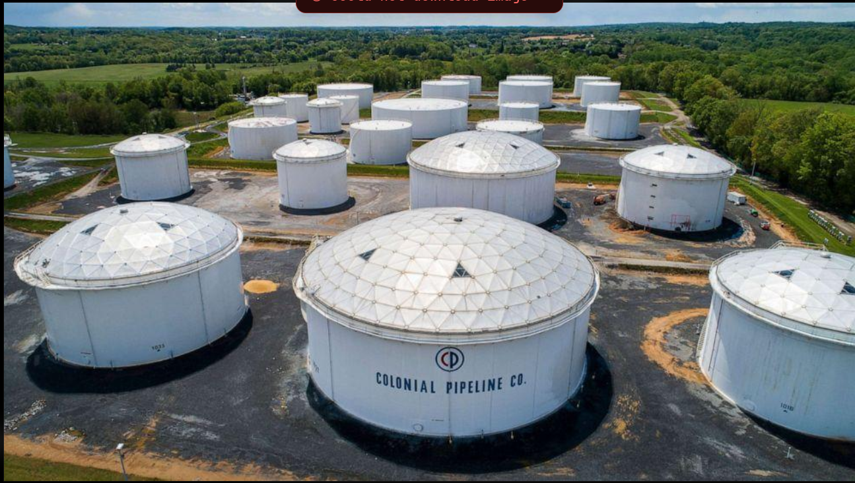
The Colonial Pipeline ransomware attack was a major cybersecurity incident that occurred in May 2021 in the United States. The attack affected one of the country's largest fuel pipeline operators.

3. What happened, who was affected, and what could have reduced the risk?
What happened:
- On May 7, 2021, Colonial Pipeline experienced a ransomware attack.
- The attack was carried out by a cybercriminal group known as DarkSide.
- Attackers compromised the company's network and deployed ransomware.
- Colonial Pipeline temporarily shut down some of its pipeline operations as a precaution.
- The company paid approximately 75 bitcoins as ransom. The FBI later recovered approximately 63.7 bitcoins.
FBI+1
Who or what was affected?
- Colonial Pipeline's computer systems and business operations.
- Fuel transportation and distribution across parts of the United States.
- Businesses and consumers who depended on the pipeline for fuel.
- Fuel availability was disrupted, causing shortages and public concern in affected areas.
FBI+1
What could have reduced the risk?
- Using multi-factor authentication (MFA) for remote access.
- Using strong, unique passwords for employee accounts.
- Keeping offline and regularly tested data backups.
- Separating business IT networks from operational technology (OT) networks.
- Monitoring network activity to detect suspicious access.
- Regularly updating systems and security software.
CISA and the FBI specifically recommended network segmentation, tested backups, and other security measures to reduce ransomware risks.
cisa.gov+1
Official incident references:
- FBI – Colonial Pipeline ransomware incident
- CISA – DarkSide ransomware security advisory
- Department of Justice – Ransom recovery

4. Table of five cybersecurity threats, their effects, and prevention methods
Cybersecurity threat | Possible effects | Prevention method
Phishing | Password theft, financial loss, unauthorized account access | Verify senders and avoid suspicious links
Malware | System damage, information theft, unauthorized access | Use updated antivirus software
Ransomware | Files become inaccessible and business operations are disrupted | Maintain offline backups
Password theft | Attackers gain access to personal or business accounts | Use strong passwords and MFA
Data breach | Confidential information is exposed or stolen | Use encryption and access controls

5. Five warning signs of a suspicious email or message
- Unknown sender: The message comes from an unfamiliar or suspicious email address.
- Urgent language: It creates pressure by saying your account will be blocked or suspended immediately.
- Suspicious links: It contains links to websites with unusual or misspelled domain names.
- Unexpected attachments: It includes unexpected files or attachments that you were not expecting.
- Requests for sensitive information: It asks for passwords, banking details, OTPs, or other confidential information.
The FBI also recommends checking email addresses and URLs carefully, avoiding unsolicited links and attachments, and enabling MFA.
FBI

6. Safety precautions followed during this task
During this assignment, I followed these safety precautions:
- I did not open suspicious email attachments.
- I did not download unknown files.
- I did not click suspicious links.
- I did not contact suspected attackers.
- I used publicly available cybersecurity information for research.

Conclusion
This assignment helped me understand common cybersecurity threats and how they affect individuals, businesses, and organizations. The Colonial Pipeline incident demonstrated how a ransomware attack can disrupt important services and affect thousands of people.
Learning to recognize phishing messages, use strong passwords, enable MFA, maintain backups, and update security software can help reduce cybersecurity risks.
Reference: FBI – Spoofing and Phishing and CISA – DarkSide Ransomware Advisory.

